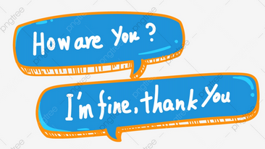
English Vocabulary: “Hello”, “How are you?”, “I’m fine”

Consider the following conversation:

A: Hello. How are you?
B: I’m fine, thank you. And you?
A: I’m fine, too, thanks.

This conversation is Lesson One in any basic English
course, but in real life, people don’t say this! Let’s take
a look at what people really say.

1) Hello

This greeting is very formal and is rarely used between friends and family. Here are two more informal options:

- Hey!
- Hi!

The word “Hey” can also be used to attract somebody’s attention, but it is a little impolite. A more polite way is to say “Excuse me”. For example:

“Hey! Can I have a menu?” (impolite)
“Excuse me. Can I have a menu?” (polite)

Note: Never use the word “Oi”, as it is rude and aggressive!

2) How are you? I’m fine.

This question and response are also very formal and are not generally used between friends and family. Here are some more options:

a) Formal

- How are you?
- How are you today?
- How are you this morning / this afternoon / this evening / tonight?

Possible responses:
- I’m fine, thanks.
- I’m well, thanks.
- I’m very well, thanks.
- I’m great, thanks.
- I’m fantastic, thanks.
- etc.

b) Informal

- How’s it going?
- How are you doing?

Possible responses:
- Good.
- Pretty good.
- Pretty well.
- Quite good.
- Not bad.

c) Very informal (usually between friends)

- What’s up? (In the U.S.A. it is pronounced as “Wassup”)
- What’s going on?
- What’s new?

Possible responses:
- Not much. You?
- Nothing. You?
- Nothing much. You?

d) After a long time

- How have you been?
- How have you been recently?
- How’s life?
- How’s everything?
- How are things?

Possible responses:
- I’m good, thanks.
- Pretty good, thanks.
- Excellent, thanks.
- Not bad, thanks.
- Not too bad, thanks.

Suggested videos:

https://www.youtube.com/watch?v=_RiXCJtCieA

https://www.youtube.com/watch?v=W16qzZ7J5YQ

